UNIWA V808G Big Button Phone

Type of device: Mobile
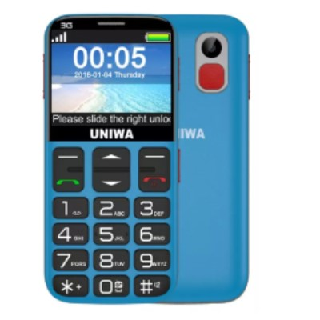

Actual Display Size : 2.31 inches
Button Type : Physical Keypad
Operating System : Android
Version Number : Android 9
Network Capability : 3G
Year of Release : 2018
Average Price : as of 16 11 2021

Accessibility Features:

Cognitive
- Additional Instructions
- GPS
- Simple Instructions
- Simple Reminders
Voice Notes

Hearing Impairment and Deaf
- Allows for sign language communication
- Bluetooth or Wi-Fi
- Front Facing Camera
- Text Messaging/SMS
- Vibrating Alerts - Adjustable
Visual Alerts - Incoming Calls

Vision
- Battery Alert - Audible
- Bluetooth or Wi-Fi
- Brightness Adjustable
- Key Marker – Raised '5'
- Key Numbers - Standard Layout
- Key Press - Vibration or Click
- Power Cue
Text Size Adjustable

Speech
- Allows for sign language communication
- Bluetooth or Wi-Fi
- Messaging Options - Email
- Messaging Options - IM
Messaging Options - MMS

Physical
- Bluetooth or Wi-Fi
- Headset - plug connected
- Physical Dialling Keys
Speaker-phone option

How and where to get it from?
You can buy this phone from BigButton, and other retailers.

More information is available on:
BigButton Webpage

